IMPACT OF SOCIAL MEDIA ON YOUTH AT ALANKHAN PALLI ,KADAPA

G. SALEEMA H.T NO 20440101014

IIB.A HEP[TM]



Project Mentor
Dr.P.V.SUBBA REDDY

Lecturer, Department of Political Science

Community Service Project Submitted in Partial Fulfillment for the Degree in Bachelor of Arts Awarded by Yogi Vemana University, Kadapa, A.P.

SKR & SKR GOVT.COLLEGE FOR WOMEN (A),KADAPA
MAY/JUNE 2022

ACKNOWLEDGEMENT
It is a matter of pleasure to glance back and recall the path one traverses during the days of hard work and pre-perseverance. It is still juncture to recall all the faces and spirit in the form of teachers, friends near and dear ones. I would consider this work nothing more than incomplete without attending to the task of acknowledging the overwhelming help I received during this endeavor of mine.
I have lack of words in expressing our gratitude and sincere regards with heartfelt thanks to my Mentor, SK Dr.P.V.SUBBA REDDY R & SKR GCW[A] KADAPA, his towering presence and inspiring guidance, scientific proficiency, constructive criticism and wholehearted cooperation in the preparation of this manuscript. I wish to express my bountiful appreciation and thanks for the pains he has taken for critically going through the manuscripts and for the assistance rendered during the preparation of the project. I must confess that it has been an honorfor us to be associated with him during the course of Survey.
I am grateful to M.VEERABHADRAIAH, SKR & SKR GCW[A] KADAPA to his kind cooperation during the Period of Community Service Project.
I humbly thank, SKR & SKR GCW[A] KADAPA, for all the support during my study period.
I take this opportunity to thank all those who helped me directly or indirectly in this endeavor.

Name: G.SALEEMA, 20440101014

SKR & SKR GOVT.COLLEGE FOR WOMEN (A), KADAPA

CERTIFICATE
This is to certify that the Community Service Project titled ‘Impact of Social - Media on Youth at Alankhan Palli, Kadapa is a bonafide work carried out by G. saleema (20440101014)IIBAHEP[TM] under the mentorship of Dr. P.V.SUBBA REDDY Lecturer, Department of Political Science, for the partial fulfillment of B.A Degree awardedby Yogi Vemana University, Kadapa,A.P.

SignatureoftheProjectMentor Date:

SignatureoftheCommunityServiceProject Coordinator Date:

Signatureof theSubjectExpert Date:

Sealofthe Institution:

ABSTRACT
Social Networking sites provide a platform for discussion on burning issues that has been overlooked in today’s scenario. This survey is conducted to check the impact of social networking sites in the changing mind-set of the youth. It is survey type research and data was collected through the questionnaire. 100 sampled youth fill the questionnaire, while -random sampling techniques were applied to select sample units. Collected data was analyzed in term of frequency, percentage, and mean score of statements. Findings show that the Majority of the respondents show the agreements with these influences of social media. Respondents opine Face book as their favorite social media form, and then the like Youtube as second popular form of social media, the primary place for them, 46 percent responded connect social media in educational institution computer labs, mainstream responded as informative links share, respondents Face main problem during use of social media are unwanted messages, social media is beneficial for youth in the field of education, social media deteriorating social norms, social media is affecting negatively on study of youth. Social media promotes unethical pictures, video clips and images among youth, anti-religious post and links create hatred among peoples of different communities, Negative use of social media is deteriorating the relationship among the countries.

TABLE OF CONTENTS

S.no | Title of Content | Page No
 | Introduction, Scope, Objective and Methodology | 1-4
 | Project Specification | 5-6
 | Problem Identified | 7
 | Analysis of the Problem | 8
 | Community awareness Programmes | 9
 | Intervention/Service Programme | 10
 | Short-term and Long-term Action plans for Implementation | 11-14
 | Recommendations and Conclusions | 15
 | References | 16

ANNEXURES
S.no | Title of Content | Page No
1. | Survey: Questionnaire | 17-18
2. | Analysis of the survey done on a Google Form | 19-24
3. | Geo tagged photographs of the field visit and activities with captions and dates | 25-26
4. | Community Exit Report | 27-30

INTRODUCTION
The study focuses on the impact of social media on youth. Technology and innovation are regarded to be the very prime importance for human life, and we must know how to handle it accordingly. It is vital to teach young people about the use of social media to Enhance in their careers and self-improvement. Technology has managed to secure within our body, human brain and even emotions.
How social media effect youth does stated that social media, like a coin, have a beneficial and negative effect on young people. It encourages youth to succeed and pull them down, but youngsters need to be alert. Youth communicate with many individuals and support themselves in their professions. Social media lets youth share their views with others.
Social media promotes deceptive posts, messaging, photographs that give rise to conflicts in between them. Such posts are deteriorating the affiliations and relations between nations. As youngsters are immature, they are becoming victims of cyber bullying. This impacts young people mental and physical health and may also leads to depression and self-harm. Because there is a lack of confidentiality and security on the social media platforms, it is possible that a third party would misuse sensitive information. Studies have found that children and teenagers benefit from improving Communication, social linkages, and technological skills. Social media is really a significant aspect in this world. In general, social media is described like any interactive medium or application which enables people to communicate digitally and could be differentiated from conventional media (e.g., television) by the way that users can both access and produce content. Within this broad description, social media can include websites (e.g. Facebook, What’s app, Snapchat, TikTok), instant messaging apps, mobile gaming tools, YouTube, and more.

The more extensive usage social media is correlated with numerous mental health issues which include anxiety of self-image and eating disorders and other problems. In addition, outcomes of these studies have indeed been contradictory, with several suggesting a slight but substantial negative influence of social media use on mental health. Increased occurrence of certain mental health conditions, such as depression and suicide have raised dramatically amongst adolescents in recent years, with suicide rates in youth aged 10-24 rising by 56% between 2007 and 2017.
One growing problem that really has captured the interest of young people is body dissatisfaction. Low self - esteem refers to unwelcome and negative thoughts and feelings about one's beauty that tend to rise in our younger generation. Social networking promotes the concept of a perfect body, as it can be connected to nearly all channels of mass media.
A systematic overview of research observed that use of social media turned into related to body photo issues and disordered consuming. In a randomized examine, girl individuals suggested greater bad temper after simply 10 mints of perusing their Facebook profile in contrast to those who have visited the personality-neutral website exploitation. In addition, participants who were over-evaluated appeared to make an escalated decision to improve the look of their face, hair or skin after spending time on Facebook, compared to those who were surfing the control website.
An observational look found that spending quite a few hours a week on the use of electronic media was inversely correlated with self-reported satisfaction, life pleasure and self-esteem, while time is spent on off-screen sports (in-character social relationships, recreational activities or exercise, traditional media, homework, religious services, paid work) was undeniably correlated with mental well-being, among the youth. Other data analysis has associated spending more than 2 hours an afternoon on social media platforms and personalized digital devices with excessive suicide costs and depressive signs among teenage girls, and although young people who have endured high levels of face-to - face socialization have been particularly affected by the negative effects of even more time on-line
SCOPE
The study seeks to find out the impacts of social media among the youth on behavior change. While the study recognizes that new interactive technologies have impacts on other age groups outside the youth bracket, and as such this study will limit itself only to the youths in Maruthi Nagar. Majority of the youth are shifting from Television media to social media as it has influenced them. Social media influences youngster’s life styles and it is helping them to create a network throughout the world. Social media makes it effortless to make relationship with anyone by expressing their likes and dislikes, which can be easily done. They are able to connect with every one through texting, sharing pictures and videos to their friends and the information can be passed on immediately at cheaper cost. Social networking offers a platform to discuss some burning current issues. Social media is a channel through which they are able to share their thoughts and feelings with their peers. As the youth get older, they are in dilemma as what can be done, they get guidelines for the problems in their life. Help students to share information regarding the assignments to be submitted. Ticket booking for a movie show, a hotel and flight and train tickets for local as well as for an overseas travel trip can be done immediately. Social media has facilitated political change as the youth are more aware of politics.

OBJECTIVIES
The main objective of this study is to analyses the impact of social media on youth. It also to assess how youth use social media in their day-to-day life and its impact on youth in terms of educational learning, entertainment, in quest of job opportunities, communication, enhancing skills, and online shopping. The following are the major objectives:
- To analyze the influence of social media on youth social life
- To assess the beneficial and preferred form of social media for youth
- To evaluate the attitude of youth towards social media and measure the spending time on social media
- To recommend some measure for proper use of social media in right direction to inform and educate the people.
METHODOLGY
In this study, 100 students have selected as a simple random sample from Maruthi Nagar, Kadapa by using Cochran formula (Bartlett, Kotrlik and Higgins, 2001). Questionnaire was designed to collect primary data from the selected sample. In questionnaire, Likert scale (Strongly Agree, Agree, Disagree, and Strongly Disagree) was utilized. After collecting this primary data, its descriptive statistics are measured by using software “SPSS” (Statistical Package for the Social Sciences).
PROJECT SPECIFICATION
This study is expedient to apply social media in right direction for youth and create cognizance among youth that proper use of social media become a solid tool to educate, inform and groomed the mentality level of youth social media refine their living style of public especially for youth it is also create an responsiveness that how it is effecting the social life the deteriorate social norm, society standards and ethics of society and create awareness among youth the aspect of social media.
Social media having various impacts on youth’s life in both ends some time impacts are in the favor of youth’s social life and sometimes theses impact are negative to its user. Social Media might be sometimes seemed like just a new set of cool tools for involving young people.
Sometimes you may use it this way and that's ok there are some pretty cool new tools around but the emergence of social media potentially has a bigger impact than that. It impacts upon young people who are growing up in an age where media is not about broadcast content from the TV, but is about interactivity, multimedia and multi-tasking. And it impacts upon organizations who need to remain relevant to a new generation, and who find their own work and structures being changed by changing communication tools and patterns of communications.
Time Wastage:
Students, while searching and studying online, get attracted to using social media sites and sometimes they forget why they are using internet. This wastes their time and sometimes students are not able to deliver their work in the specified time fram
Low Grades:
Students get low grades in school due to lack of the desired information and writing skills.
Loss of Motivation in Students:
The student's motivational level reduces due to the use of these social networking sites. They rely on the virtual environment instead of gaining practical knowledge from the real world.
Effect on Health:
The excessive use of these sites affects the mental as well as physical health. Students do not take their meals on time and take proper rest. They take excessive amount of coffee or tea to remain active and focused which effects negatively on their health.
Lack of privacy:
Social networking has drastically changed the way people interact with their friends, associates and family members. Although social networks, like Twitter, Facebook, Google+, YouTube, play a major role in our day to day lives, it poses serious privacy risks. When using these social media sites, it is quite important to know and understand the privacy risks involved in it.
PROBLEMS IDENTIFY
Social media networking of adolescentshasa vital role to play in the advent and development of psychopathology. Online community social interactions are described as significant risk factors for mental health issues. Social media users are radically subjected to idealized self-shows. This poses a danger to youngsters' potential to appear superficial, but the awful effect may depend on a form of social media interaction.
A survey report published on social media chimps in the form of info graphic reflects the impact of social media to even greater extent. Girls aged 16-17 years are most inclined to cyber bullying attacks. The reports above altogether gave a mixed bag of reaction. While they put social media in a good perspective, most of the times they also highlight the downside of their excessive use of social media.
“Social Media and its effects on youth”, revealed that victims face two such major threats online are cyber bullying and electronic aggression. Having understood the different impact from social media usage, researcher made an attempt to study the impact of social media on the youth.
ANALYSES OF THE PROBLEM
This study will try to find out the impact that social media has on the youth‘s behaviour. Technology has many positive aspects but, in the wrong hands, it can become dangerous. For the young people it is experiments to do what they feel is good or exciting to them and the friends and at the same time avoid adult supervision. Opines that for teenagers, the online realm may be adopted enthusiastically because it represents their‘ space, visible to the peer group more than to adult surveillance, an exciting yet relatively safe opportunity to conduct the social psychological task of adolescence – to construct, experiment with and present a reflexive project of the self in a social context, as well as, for some, for flouting communicative norms and other risk-taking behaviors.
• They are moved away from their career and personal development.
• Youth are addicted to social media by sharing pictures and chatting unnecessarily
• As parents are busy with their day-to-day activities, they are unable to spare their time with their Children. Social media helps the present youth to get rid of from their boredom.
COMMUNITY AWARNESS PROGRAMMES CONDUCTED w.r.t. THE PROBLEMS AND THEIROUTCOMES.
- Community Awareness is generally defined as knowledge created through interaction between community people and its environment, a setting bounded in space and time. It involves states of knowledge as well as dynamic process of perception and action. It is the knowledge that must be maintained and kept updated to complete some tasks in the environment. Community Awareness generation is considered as core element of successful disaster risk reduction.
- An ideal campaign has to be sustained over time to foster changes in social and behavioural norms.
- The strategy for generating community awareness should be designed and implemented with a clear understanding of local perspectives and requirements with materials reflecting local conditions in a community.
- The strategy should target all sections of the society including decision makers, professionals, public and individuals living in vulnerable areas.
- It postulates that different types of messages and delivery systems should be used to reach various target audiences at different community.
- Community awareness generation framework should should follow the target audience’s segmentation i.e. grouping by demographic ,social , effective , oriented which is attractive for the community people.
- People are especially motivated by approaches in which they themselves participate in a solution, and especially when they believe it is their own idea.

INTERVENTION / SERVICE PROGRAMMES TAKEN UP
We conducted a rapid response overview of systematic reviews. We used a sensitive search strategy to identify systematic reviews and included those that focused on interventions allowing two-way interaction such as discussion forums, social networks (e.g., Facebook and Twitter), blogging, applications linked to online communities and media sharing at Maruthi Nagar, Kadapa.
Most interventions addressed by the reviews included online discussion boards or similar strategies, either as stand-alone interventions or in combination with other interventions. Seven reviews reported mixed effects on health outcomes and healthy behaviors. We did not find disaggregated analyses across characteristics associated with disadvantage, such as lower socioeconomic status or age. However, some targeted studies reported that social media interventions were effective in specific populations in terms of age, socioeconomic status, ethnicities and place of residence. Four reviews reported qualitative benefits such as satisfaction, finding information and improved social support.
Social media interventions were effective in certain populations at risk for disadvantage (youth, older adults, low socioeconomic status, rural), which indicates that these interventions may be effective for promoting health equity. However, confirmation of effectiveness would require further study. Several reviews raised the issue of acceptability of social media interventions. Only four studies reported on the level of intervention use and all of this reported low use. More research on established social media platforms with existing social networks is needed, particularly in populations at risk for disadvantage, to assess effects on health outcomes and health equity.

SHORT- TERM AND LONG-TERM ACTION PLANS FOR IMPLEMENTATION
Social media allows teens to create online identities, communicate with others and build social networks. These networks can provide teens with valuable support, especially helping those who experience exclusion or have disabilities or chronic illnesses.
Teens also use social media for entertainment and self-expression. And the platforms can expose teens to current events, allow them to interact across geographic barriers and teach them about a variety of subjects, including healthy behaviors. Social media that's humorous or distracting or provides a meaningful connection to peers and a wide social network might even help teens avoid depression.
Social media refers to all applications and websites or blogs that enable people around the globe to interconnect via the internet, chat, and share content, video call among many other functionalities it offers to its users. For a person to be a member of any social media, he or she has to first signup and then sign in to access content and be able to share and chat with other users of that social media platform. Some of the common and widely used social media platforms include Facebook, Twitter, WhatsApp, Snapchat many among others.
Over the past two decades, social media have gained so much growth and fame worldwide to an extent that many researchers are now interested in learning more about these social platforms and their effects on the community. Despite the fact that almost everyone in the community is connected to at least one social media platform, the youth and teenagers are the leading and most fanatic of these social platforms to the point that they even social network while in class or even church. It is to this light that researchers have found that these social sites impact the lives of our youth in a society a great deal in terms of morals, behavior and even education-wise.
The use of social media has both negative and positive impacts on our youths today. In this paper, I aim to bring to light the impacts of social media specifically to the youth of this generation. These impacts are both positive and negative.
The positive impacts of social media on the youth today include making them up date on the events happening around the globe and also enables them network and stay connected with their fellow youths and friends without physical meetings. It bridges the gap between friends since a person say in Africa can network and interact with his or her friend in the United States. This in turn helps in strengthening relationships say amongst classmates in high school or college, who after finishing school, moved to different locations around the world.
Additionally, youths can create pages and groups in the social media platforms based on their professions, faith among other dimensions of their lives and this leads to more connections being built and more opportunities being opened for their respective disciplines. This can even lead to more employment opportunities being created for the unemployed youths. From the many interviews carried daily, youths say that a social media platform make their lives enjoyable, efficient and easier and has also become their lifestyle.
Even though social media sites seem to connect more people and make them stay up to date, it leads to isolation socially. It reduces the number of face-to-face interactions amongst the youths because they normally spend most of their time on these online social platforms. An evaluation from a number of studies done by various scientists show that social isolation can cause a number of effects such as physical, emotional, mental and psychological issues in these youths. This can in turn lead to depression, anxiety and many other problems. It also leads to misspelling of words and misuse of words and tenses through the use of short forms and abbreviations.
This has a high negative impact more so on students because it affects their language capabilities directly and this leads to poor grades in languages.Also it exposes young teens say below eighteen years to online predators who get to woo them into sexual acts such as lesbianism and other general sexual misconducts. It also exposes these teens to pornographic content being spread in some the social groups online. This in turn leads to early pregnancies amongst young girls causing them to drop out of school. It also can lead to contraction of sexually transmitted diseases such as HIV and this can lead to early deaths of our young generation. The morals of these teens are also tampered with as they now get access to immoral literature and videos.
Spending long hours chatting in social media sites also decreases productivity amongst the youths. This in turn causes the youths not to be self-dependent and instead depend on their parents and families for upkeep. The long hours wasted online on social media can be channeled to productive activities that can enable one earn a living or even acquire an education for instance through online tutorials and make good use of online research materials.
Social media also provides a good platform where cyber theft and bullying is done and this increases the chances and incidences of identity theft. This has a number of risks to the youths as their personal information can get stolen since it is stored in some locations they do not know about or whose security is in not known or is questionable.
Social platforms also encourage the spread of wrong information and news majorly aimed at tainting other peoples’ names or other groups of interest such as political or religious groups. This in turn leads to fights and enmity between the concerned parties and this can lead to divisions amongst tribes or people from different ethnicities and tribes
It can also lead one to join groups of cults and illuminati people, which in turn can also lead to frequent killings of people in society especially loved ones as a sacrifice to these cults.
In conclusion, social networking has been proved to have both positive and negative effects on our youths. Individuals should make a conclusion whether to go on using the sites or stop or even moderate on their usage. Parents should guide and advise their children on current matters like the usage of social media and warn them of its negative impacts to them when misused or overused. The education curriculum also should be revised so that it can include social media studies in its disciplines so as to alert students that they need to be careful in their social media usage.

RECOMMENDATIONS AND CONCLUSIONS
This study investigates the effects of social media on youth. Results shows that social media plays important role in learning and job opportunities. Teenagers mostly use social media for communication with friends and families. Results also depicts that social media cause health problems and affect our cultures. While using social media, users have to remember the cultural values, social norms, and Islamic values.

On the basis of analysis, the major recommendations are:
❖ Social media should be used for positive purposes.
❖ Use of social media in informative way enhance the skills, and abilities.
❖ To minimize its negative effects Government has to take some strict actions. Government should ban immoral websites.
❖ A Strong recommendation for the government is to make policy or community that check which immoral websites are used by which users.
❖ Government has to make policies to check out unfair reporting of media which ruin the society.
❖ A strong recommendation for the users of social media is that they have to remember the purpose of using social media and always use the informative sites.
❖ Adolescence should use their time wisely instead of wasting their precious time on other social networks like WhatsApp, Twitter, Facebook, and YouTube.
❖ To secure the future of children, teachers and parents should check out what they actually are doing on social media.

ANALYSIS 0F THE SURVEY DONE ON A GOOGLE FORM
Iprepared a Google form and went to the residencies of the Maruthi Nagar, Kadapa and asked them to fill the forms20% are10-18 age group, another 20%are 19-30 age group and other 60% are above 30 age group people respondents.In the survey 41.7% male respondents and 58.3% female respondents.
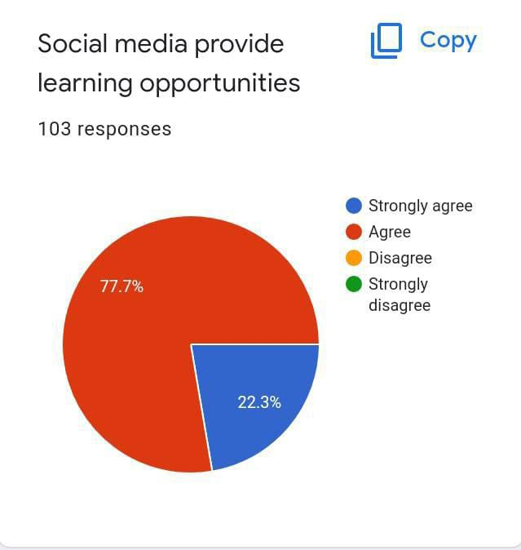
The above pie chart represents total percentage of people responded to the statement “social media provides the learning opportunities”. 74 percent of the people strongly agreed and 26 percent of the people agreed with the term.
Agree/ Disagree | Number of Responses | Percentage
1. Strongly Agree | 22 | 22.3%
2. Agree | 77 | 77.7%
3. Disagree | 0 | 0%
4. Strongly Disagree | 0 | 0%

The above table shows the number of responses given regarding social media provides learning opportunities. As 22.3% responses were given to strongly agree and 77.7% voted agreed. None of them voted for strongly disagree and disagree. So the percentage comes with the number of responses. Hence, we can conclude that social media provides numerous learning opportunities. Social media is a best platform to gain knowledge in required aspects when efficiently us.
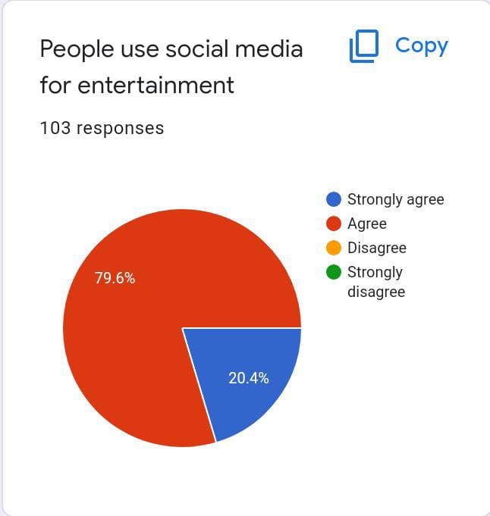

The above pie chart represents total percentage of the people responded about the aspect “people use social media for entertainment”. 72 percent of the people strongly agreed for it and 28 percent agreed for the statement.
Agree/Disagree | Number of Responses | Percentage
1.Strongly Agree | 20.4 | 20.4%
2. Agree | 79.6 | 79.6%
3. Disagree | 0 | 0%
4. Strongly Disagree | 0 | 0%

The above table describes the number of responses recorded to the statement “people use social media for entertainment”. 72 of them strongly agreed and 28 of them agreed. None of them disagreed with it. So the percentage comes with the number of the responses.
Hence, we can conclude that entertainment is also a purpose of the social media usage by people. Social media includes many apps and applications which entertain people. Besides learning, social media also provide entertainment

.
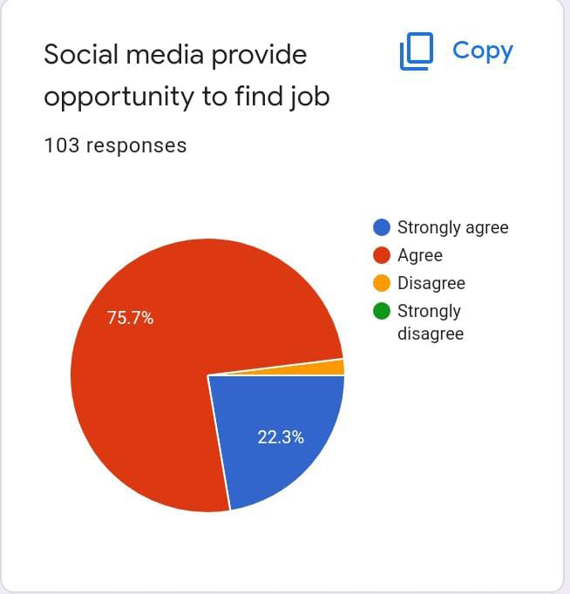
The above pie chart represents total percentage of people responded to the aspect “social media provide opportunity to find job”. 69 percent of the people strongly agreed and 31 percent of the people agreed. None of them disagreed with it.
Agree/Disagree | Number of Responses | Percentage
1. Strongly Agree | 22.3 | 22.3%
2. Agree | 75.7 | 75.7%
3. Disagree | 2 | 2%
4. Strongly Disagree | 0 | 0%
The above table represents the number of responses recorded regarding “social media provides opportunities to find jobs”. 69 out of 100 strongly agreed and 31 of them agreed with it. So, the percentage comes with the number of responses.
Hence, we conclude that social media provides opportunities to find job. Many educational platforms provide training and heirs the unemployed. Hence social media is also used to find jobs.

. 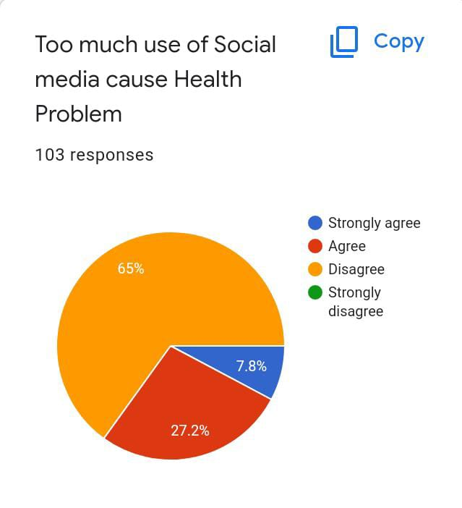

The above pie chart represents total percentage of responses recorded to the aspect “too much use of social media cause health problem”. 85 percent strongly agreed with it, 14 percent agreed with it. 1 percent out of 100 disagreed with it.
Agree/Disagree | Number of Responses | Percentage
1. Strongly Agree | 7.8 | 7.8%
2. Agree | 27.2 | 27.2%
3. Disagree | 65 | 65%
4. Strongly Disagree | 0 | 0%
The above table shows the number of responses recorded regarding health issues caused by too much usage of social media. The percentage comes along the number of responses recorded.
Hence, we can conclude that most of the people strongly agree that “too much use of social media cause health problems”. As people get easily addicted to it which leads to visionary problems, insomania, effect to mental health sometimes even cause mental trauma. So limited and efficient usage is recommended without addiction

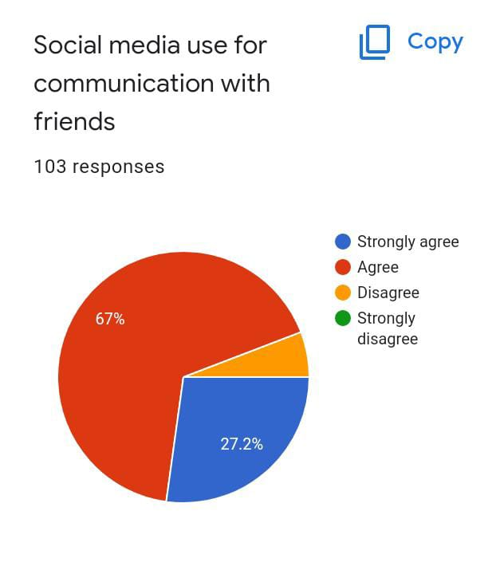
The above pie chart represents total percentage of responses recorded to the aspect “social media used for communication with friends”. 70 percent of the people strongly responded and 30 percent of the agreed with it. None of them disagreed with it.
Agree/Disagree | Number of Responses | Percentage
1. Strongly Agree | 27.2 | 27.2%
2.Agree | 67 | 67%
3.Disagree | 5.8 | 5.8%
4.Strongly Disagree | 0 | 0%
The above table shows number of responses recorded regarding communication with friends via social media. Majority of the people strongly agreed with it. The percentage comes along the number of responses recorded.
Hence, we conclude that social media is widely used for communication purposes. Many people use social media platforms to communicate with their long-distanced friends also. So social media plays a vital role in communication purposes.

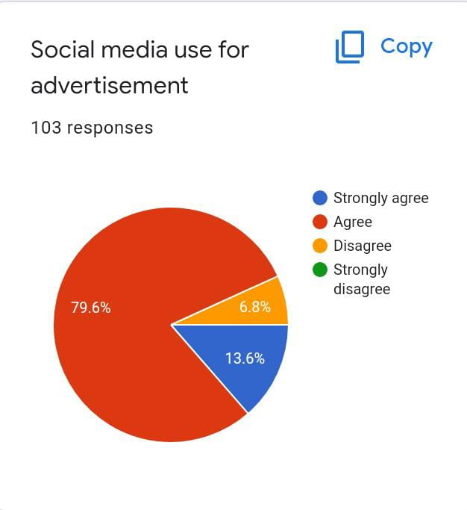
The above pie chart represents total percentage of people out of 100 responded to the query that “social media is used for advertisement”. 68 percent of the people strongly agreed and 32 percent of them agreed. None of them disagreed with it.
Agree/Disagree | Number of Responses | Percentage
1.Strongly Agreed | 13.6 | 13.6%
2.Agreed | 79.6 | 79.6%
3.Disagree | 6.8 | 6.8%
4.Strongly Disagree | 0 | 0%
The above table shows the number of responses recorded to the query that social media is used for advertising. Majority of them strongly agreed with it. The percentage comes along with the number of the responses recorded.
Hence, we conclude that social media is the best platform for advertising. Many uses social media for the purpose of advertising their products and companies. The products and the companies get popularised mostly through advertisements on social media platforms

. 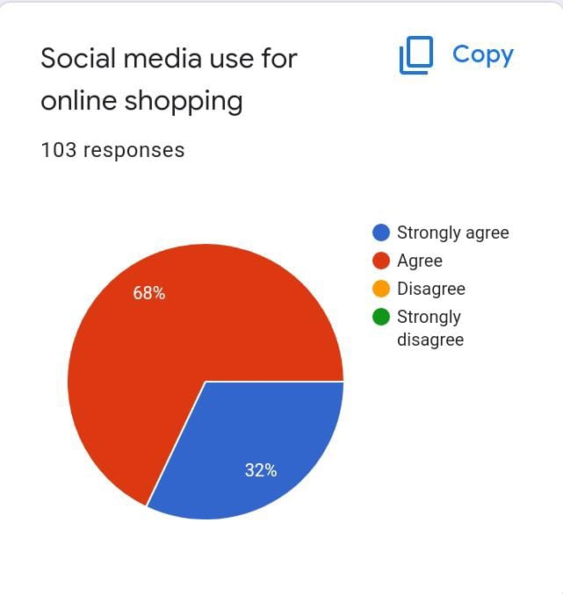

The above pie chart represent total percentage of people responded for the statement “social media is used for online shopping”. 73 percent of the people strongly agreed, 27 percent agreed. None of them disagreed with it.
Agree/Disagree | Number of Responses | Percentage
1.Strongly Agree | 32 | 32%
2.Agree | 68 | 68%
3.Disagree | 0 | 0%
4.Strongly Disagree | 0 | 0%
The above table shows the number of responses recorded for the query “social media is used for online shopping”. 73 out of 100 voted for strongly agree, 27 agreed with it. None of them disagreed with it. The percentage comes along the number of responses recorded.
Hence, many online shopping apps like Flipkart, Amazon, Ajio etc provides facilitation of online shopping for customers. Now-a-days many prefer online shopping than window shopping. So social media is also used for online shopping. Besides window shopping, online shopping is the easiest way of buying products without discomforts

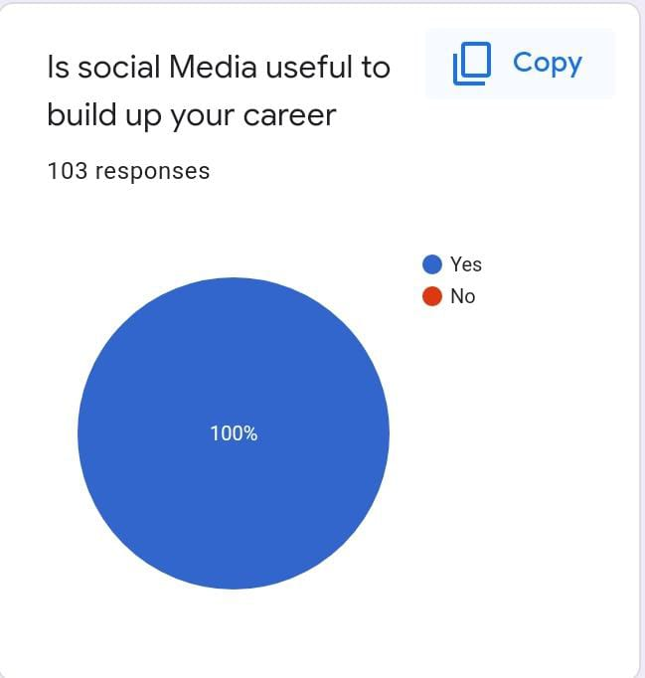
The above pie chart depicts total percentage of people responded to the question “Is social media useful to build up career”. 100 percent responded “yes”. None of them out of 100 disagreed with it.
Yes/No | Number of Responses | Percentage
1.Yes | 100 | 100%
2.No | 0 | 0%
The above table shows that total number of people responded to the question “Is social media useful to build up career”. All of them voted for yes. None of them disagreed with it.
Hence, we conclude that social media is used to build up one’s career. Social media includes many educational platforms like Unacademy, Byjus etc which provide training in required subjects and help one to build up their career. The educational sites sometimes offer jobs when they succeed their training. So, the conclusion is social media is useful to build up career.

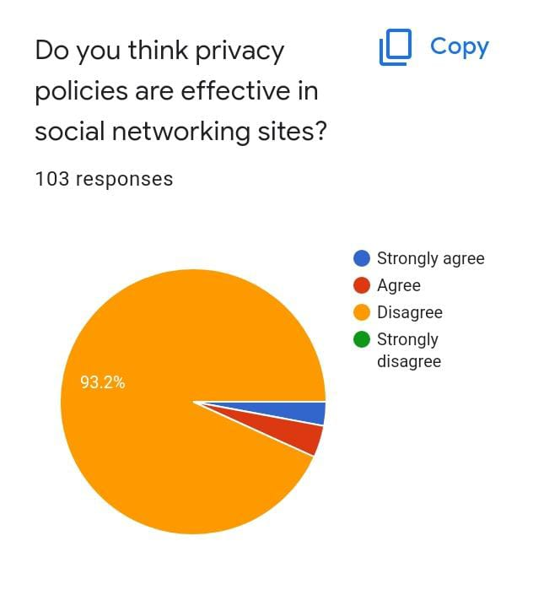

The above pie chart represents total percentage of responses given to the query “Do you think privacy policies are effective in social networking site?” 49 percent of them strongly agreed, 36 percent agreed and 14 percent disagreed and only 1 percent out of 100 strongly disagreed.
Agree/Disagree | Number of Responses | Percentage
1.Strongly Agree | 2.8 | 2.8%
2.Agree | 4 | 4%
3.Disagree | 93.2 | 93.2%
4.Strongly Disagree | 0 | 0%
The above table shoes that number of responses recorded to the question regarded to privacy policies in social media. Most of them strongly agreed and few disagreed. The percentage comes all the way number of responses recorded.
Hence, we conclude that the privacy of data of a person is very less in social media platforms. Improper care about private data lead to theft and cause misusing of the data. So, people using social media platforms should be aware of their private data. So, privacy policies are very effective in social media.

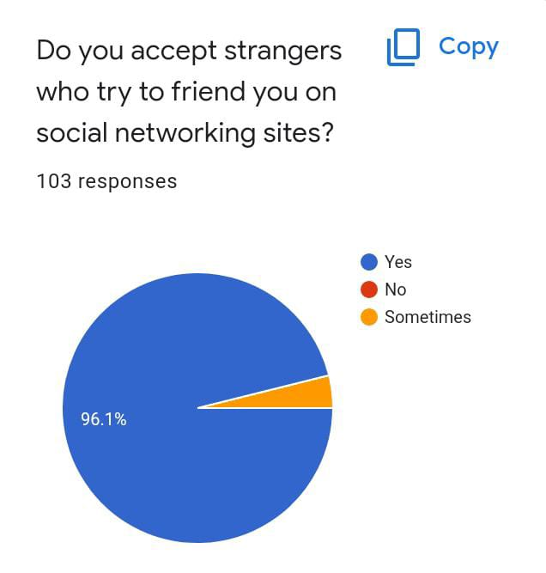

The above pie chart depicts the total percentage of responses recorded to the question “Do you accept strangers who try to friend you on social networking sites?” 86 percent did not accept, 9 percent of them accepted it and remaining 5 percent out of 100 voted that sometimes they may accept.
Yes/No | Number of Responses | Percentage
1.Yes | 96.1 | 96.1%
2.No | 0 | 0%
3.Sometimes | 3.9 | 3.9%
The above table represents number of responses recorded regarding acceptance of strangers as friends on social media platforms. Most of them preferred not to accept and few preferred to accept.
Hence, we conclude that many are not ready to accept strangers as friends on social media platforms. As the privacy in social media is very less and also due to more occurrence of fraudulent incidents, people are not willing to accept strangers as friends.

REFERENCES (Bibliography)
1. Bartlett, J. E., Kotrlik, J. W., & Higgins, C. C. (2001). Organizational Research: Determining Appropriate Sample Size in Survey Research. Information Technology, Learning, and Performance Journal, 19(1), 43-50.
2. Berson, I. R., &Berson, M. J. (2005). Challenging Online Behaviors of Youth Findings from a Comparative Analysis of Young People in the United States and New Zealand. Social Science Computer Review, 23(1), 29-38.
3. Brady, K. P., Holcomb, L. B., & Smith, B. V. (2010). The use of alternative social networking sites in higher educational settings: A case study of the e-learning benefits of Ning in education. Journal of Interactive Online Learning, 9(2), 151-170.
4. Elola, I., &Oskoz, A. (2008). Blogging: Fostering intercultural competence development in foreign language and study abroad contexts. Foreign Language Annals, 41(3), 454-477.
5. Jacobsen, W. C., &Forste, R. (2011). The Wired Generation: Academic and Social Outcomes of Electronic Media Use Among University Students. Cyberpsychology, Behavior, and Social Networking, 14(5), 275-280.
6. Kalpidou, M., Costin, D., & Morris, J. (2011). The relationship between Facebook and the well-being of undergraduate college students. Cyberpsychology, behavior, and social networking, 14(4), 183-189.
7. Livingstone, S. and Bober, M. (2003). UK children go online: Listening to young people's experiences [online]. London: LSE Research Online. Available at: http://eprints.lse.ac.uk/388/
8. Lusk, B. (2010). Digital natives and social media behaviors: An overview. The Prevention Researcher, 17(5), 3-6.
9. Tapscott, D. (1998). Growing up digital: The rise of the net generation. New York: McGraw- Hill Companies.
Available at: https://www.ncsu.edu/meridian/jan98/feat_6/digital.html
10. Waddington, J. (2011). Social networking: The unharnessed educational tool. Undergraduate Research Journal at UCCS, 4(1), 12-18.

ANNEXURES
SURVEY: QUESTIONNAIARE
Name of the respondent:
Age group:
-10 to18
-19to 30
-Above 30
1. Social-media provide learning opportunities
- strongly agree
- Agree
- Disagree
- strongly disagree
2. People use social media for entertainment
- strongly agree
- Agree
- Disagree
- strongly disagree
3.Social-media provide opportunity to find job
- strongly agree
- Agree
- Disagree
- strongly disagree
4. Social-media provide opportunity to find job
- strongly agree
- Agree
- Disagree
- strongly disagree
5. Social-media use for communication with friends
- strongly agree
- Agree
- disagree
- strongly disagree

6. Social media use for advertisement
- strongly agree
- Agree
- Disagree
- strongly disagree
7. Social media use for online shopping
- strongly agree
- Agree
- Disagree
- strongly disagree
8. Is social-Media useful to build up your career
- Yes
- No
9. Do you think privacy policies are effective in social networking sites?
- strongly agree
- Agree
- Disagree
- strongly disagree
10. Do you accept strangers who try to friend you on social networking sites?
- Yes
- No
- Sometimes

GEOTAGGED PHOTOGRAPHS
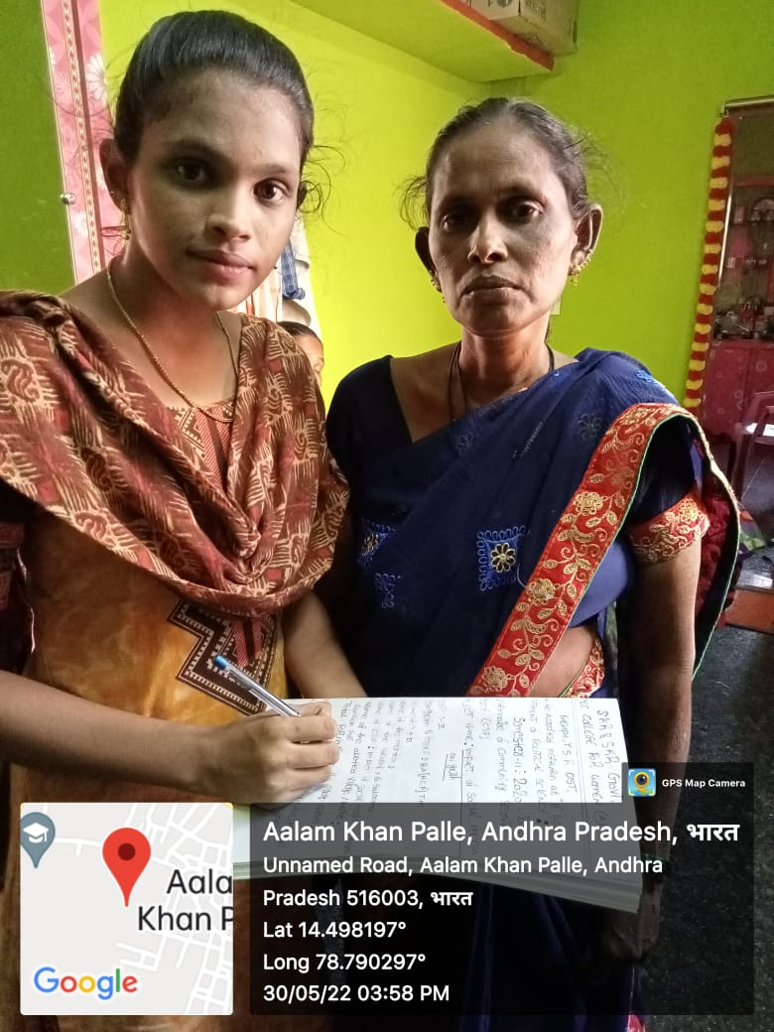
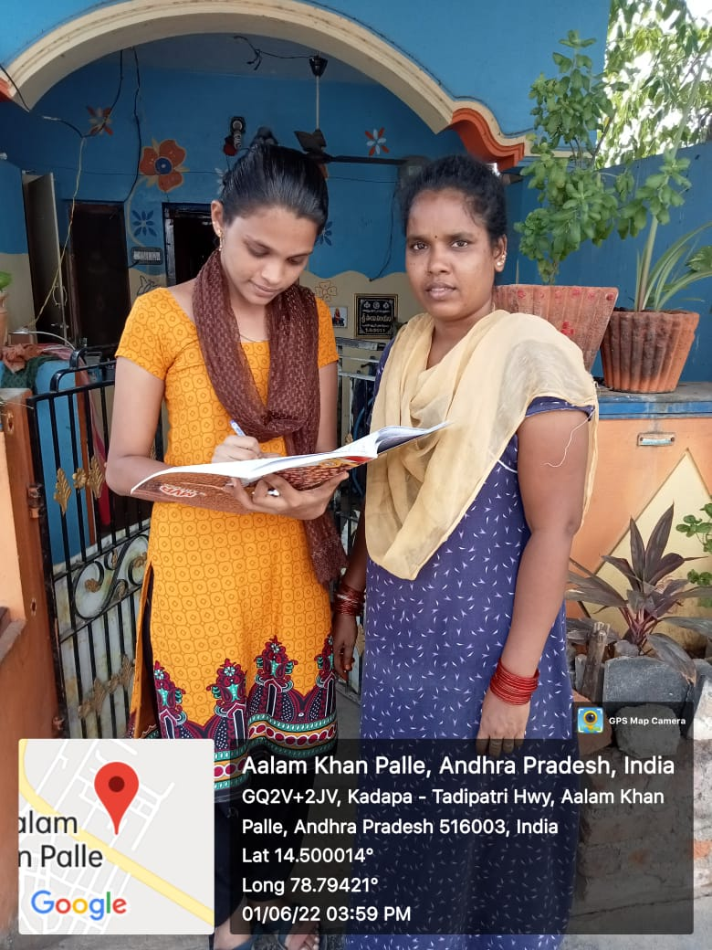

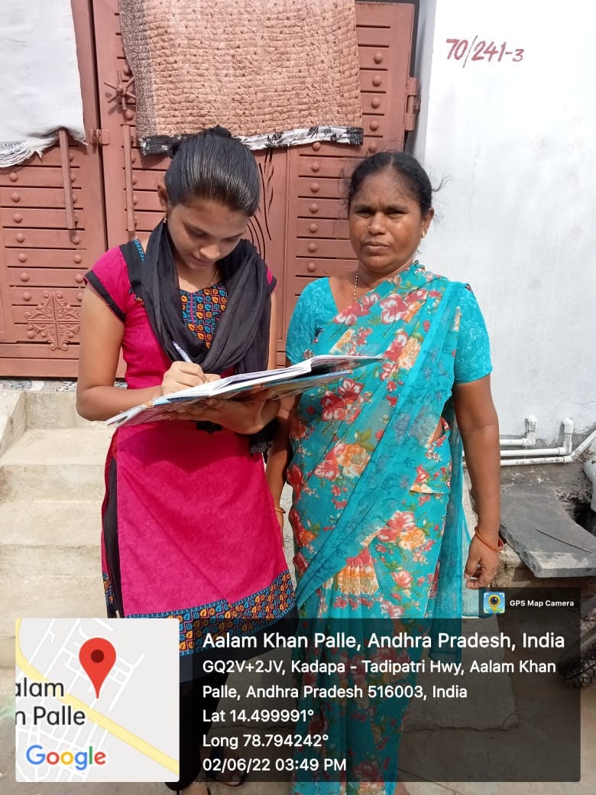

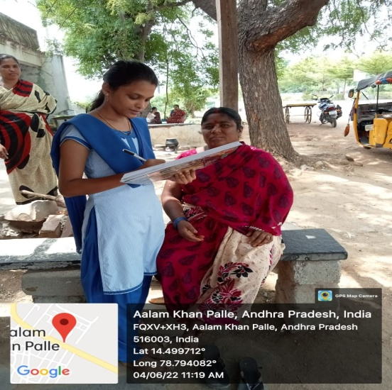

COMMUNITY EXIT REPORT
We prepared, conducted and went to the residencies of the Maruthi Nagar, Kadapa and asked them to fill the forms. As a result of using social media, the youth are learning many new things. As a result, there are many benefits to upgrading yourself. Moreover, many young boys and girls have mental problems due to study or work pressure. This social media is beneficial for their relaxation. They can talk to friends here. As a result, their mental fatigue decreases.
Similarly, it is instrumental in studying. Students can share their notes to solve their problems quickly. Again, those who work can talk to their colleagues about their official work through various social media. Even they can use any shared files, documents, etc., through this.Each of these things has a good effect on the youth of the social site.
Social media has facilitated a medium to develop discussion groups covering the subject matter in class; hence, it is a good platform for enhancing the performance of Youth. The discussion groups facilitate consultation when students are handling their assignments. Some of the discussion groups include tutors who can help students to grasp the subject matter delivered in class.
Additionally, social media has also led to more youth taking an active role in politics. Social media platforms facilitate direct access to political leaders, which has led to more leaders using the avenue to educate their followers Youth can now participate in lobbying activities, as well as influencing the political climate by voting in large numbers.
Social media is a very good avenue for accessing information relating to the issues facing global society. Young people have the opportunity of facilitating solutions to some of the issues by focusing their education toward careers that will place them in a position to tackle the challenges facing the world.
Moreover, youth are becoming more tolerant of diversity, following the ability to communicate with people from different parts of the world in various interest groups on social media. The enhancement of cultural competence is quite a desirable effect on social media.
The networks developed through interaction processes on social media also enhance access to business opportunities for youth. Young people are developing small businesses and selling goods and services through social media.
Social media has promoted the development of sedentary lifestyles among young people. Youth spend most of their time chatting with their friends on social media through smartphones and computers, and this has led to a high preference for staying indoors.
Social media is detrimental to grades in school because studies have shown that as the hours spent on social media increase, grades deteriorate for the students.
Social media has also facilitated a platform where young people can be easily victimized by individuals with malicious intentions. For instance, sex predators, identity thieves, and conmen have been targeting profiles belonging to young people because they are easily lured into their traps.
Parents have been forced to use filtering and monitoring software to protect their children, but young people are still at risk because they use social media from different gadgets away from home.
Social media have been established over the last decades. An increasingly critical place in the lives of young people, providing numerous challenges and opportunities.
As the impact of new media continues to expand, it will be important to develop evidence-based approaches to encouraging and making more effective use of social media in young people Given the value of attractive teens in alleviating possible social networking damage, a preventive tactic, will be counter-productive.
Indeed for today's youth who have no longer understand the world without social networking sites, digital interactions are the standard and the future benefits of online accessibility to efficient analytical medical information. along with digital exposure, imagination, self-Consciousness, feeling of identity and civic participation are the norm. Along with being limited to channels such as disaster lines and the Internet speech treatments, it cannot be dismissed. Nevertheless, young people today could gain from validated character and systemic interventions to help them resolve the challenges of using social media and digital media, to shield themselves from damage and to use social networking sites in a manner that supports their mental wellbeing, against the past tradition of policy proposals aimed at addressing social, cultural and monetary issues that underpin the family.

